Project Design Phase-II
Technology Stack (Architecture & Stack)

Date | 1 March 2026
Project Name | PlantCare AI – Plant Disease Detection System
Maximum Marks | 4 Marks

Technical Architecture:

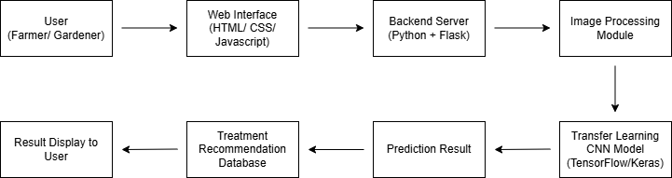

Table-1 : System Components & Technologies:
S.No | Characteristics | Description | Technology
1. | User Interface | Interface where users upload plant leaf images and view disease prediction results. | HTML, CSS, JavaScript
2. | Application Logic-1 | Handles user requests and image upload functionality. | Python, Flask
3. | Application Logic-2 | Image preprocessing and model inference logic. | Python, TensorFlow / Keras
4. | Application Logic-3 | Integration between the prediction system and the user interface. | Flask APIs
5. | Database | The system does not use a dedicated database. Disease labels and treatment information are stored locally within the application using structured data files. | Local data files (JSON / CSV)
6. | Cloud Database | Cloud database services are not used in the current implementation of the system. | N/A
7. | File Storage | Uploaded plant leaf images are temporarily stored in the local file system before being processed by the machine learning model. | Local File System
8. | External API | External APIs are not required for the current system functionality. | N/A
9. | Machine Learning Model | A transfer learning-based convolutional neural network (CNN) model is used to classify plant diseases from leaf images. | TensorFlow / Keras (Transfer Learning Model)
10. | Infrastructure (Server / Cloud) | The application is deployed on a local development environment where the backend server hosts the machine learning model and handles prediction requests. | Local Server (Python Environment)

Table-2: Application Characteristics:
S.No | Characteristics | Description | Technology
1. | Open-Source Frameworks | The system is built using open-source frameworks that support web development and machine learning model deployment. | Flask, Tensorflow, Keras
2. | Security Implementations | The system validates uploaded files and restricts unsupported formats to prevent invalid inputs. | Input Validation
3. | Scalable Architecture | The system architecture allows future integration of additional disease classes, datasets, and cloud deployment. | Modular Application Design
4. | Availability | The application can be accessed through a web interface whenever the server is running. | Local Web Server
5. | Performance | The system processes plant images efficiently and returns disease prediction results within a few seconds. | Optimized Transfer Learning CNN Model

References:
- https://www.tensorflow.org/
- https://keras.io/
- https://scikit-learn.org/
- https://www.kaggle.com/datasets/vipoooool/new-plant-diseases-dataset
- https://developer.ibm.com/articles/an-introduction-to-machine-learning/

